Web
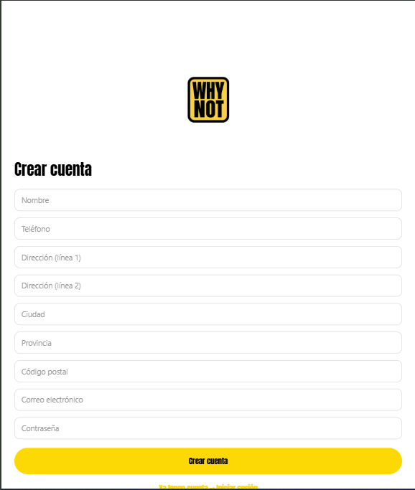
Registro no aparece el orden que te he dicho y no aparece el combo

Cuando Verifico no me lleva al home
Perfil tampoco aparece el orden de los campos establecidos previamente.
El mensaje de guardado sale de una manera que apenas se ve. Debe aparecer de una manera en la que el usuario se de cuenta de que se han modificado los datos

Al arrancar en Android aparece esto
Android Bundled 2069ms node_modules\expo-router\entry.js (1207 modules)
WARN [2025-12-28T19:28:01.427Z] @firebase/auth: Auth (11.10.0):
You are initializing Firebase Auth for React Native without providing
AsyncStorage. Auth state will default to memory persistence and will not
persist between sessions. In order to persist auth state, install the package
"@react-native-async-storage/async-storage" and provide it to
initializeAuth:

import { initializeAuth, getReactNativePersistence } from 'firebase/auth';
import ReactNativeAsyncStorage from '@react-native-async-storage/async-storage';
const auth = initializeAuth(app, {
persistence: getReactNativePersistence(ReactNativeAsyncStorage)
});
WARN Route "./(auth)/forgot-password.tsx" is missing the required default export. Ensure a React component is exported as default.
WARN Route "./(auth)/login.tsx" is missing the required default export. Ensure a React component is exported as default.
WARN Route "./(auth)/register.tsx" is missing the required default export. Ensure a React component is exported as default.
WARN Route "./(auth)/verify-email.tsx" is missing the required default export. Ensure a React component is exported as default.
WARN Route "./(tabs)/home.tsx" is missing the required default export. Ensure a React component is exported as default.
WARN Route "./(tabs)/profile.tsx" is missing the required default export. Ensure a React component is exported as default.
WARN Route "./_layout.tsx" is missing the required default export. Ensure a React component is exported as default.
WARN Route "./forgot-password.tsx" is missing the required default export. Ensure a React component is exported as default.
ERROR [FirebaseError: experimentalForceLongPolling and experimentalAutoDetectLongPolling cannot be used together.] FirebaseError: experimentalForceLongPolling and experimentalAutoDetectLongPolling cannot be used together.

Call Stack
ExpoRoot (node_modules\expo-router\build\ExpoRoot.js)
App (node_modules\expo-router\build\qualified-entry.js)
WithDevTools (node_modules\expo\src\launch\withDevTools.tsx)
ERROR [FirebaseError: experimentalForceLongPolling and experimentalAutoDetectLongPolling cannot be used together.] FirebaseError: experimentalForceLongPolling and experimentalAutoDetectLongPolling cannot be used together.

Call Stack
ExpoRoot (node_modules\expo-router\build\ExpoRoot.js)
App (node_modules\expo-router\build\qualified-entry.js)
WithDevTools (node_modules\expo\src\launch\withDevTools.tsx)
ERROR [FirebaseError: experimentalForceLongPolling and experimentalAutoDetectLongPolling cannot be used together.] FirebaseError: experimentalForceLongPolling and experimentalAutoDetectLongPolling cannot be used together.

Call Stack
ExpoRoot (node_modules\expo-router\build\ExpoRoot.js)
App (node_modules\expo-router\build\qualified-entry.js)
WithDevTools (node_modules\expo\src\launch\withDevTools.tsx)
ERROR [FirebaseError: experimentalForceLongPolling and experimentalAutoDetectLongPolling cannot be used together.] FirebaseError: experimentalForceLongPolling and experimentalAutoDetectLongPolling cannot be used together.

Call Stack
ExpoRoot (node_modules\expo-router\build\ExpoRoot.js)
App (node_modules\expo-router\build\qualified-entry.js)
WithDevTools (node_modules\expo\src\launch\withDevTools.tsx)
ERROR [FirebaseError: experimentalForceLongPolling and experimentalAutoDetectLongPolling cannot be used together.] FirebaseError: experimentalForceLongPolling and experimentalAutoDetectLongPolling cannot be used together.

Call Stack
ExpoRoot (node_modules\expo-router\build\ExpoRoot.js)
App (node_modules\expo-router\build\qualified-entry.js)
WithDevTools (node_modules\expo\src\launch\withDevTools.tsx)
ERROR [FirebaseError: experimentalForceLongPolling and experimentalAutoDetectLongPolling cannot be used together.] FirebaseError: experimentalForceLongPolling and experimentalAutoDetectLongPolling cannot be used together.

Call Stack
ExpoRoot (node_modules\expo-router\build\ExpoRoot.js)
App (node_modules\expo-router\build\qualified-entry.js)
WithDevTools (node_modules\expo\src\launch\withDevTools.tsx)
ERROR [FirebaseError: experimentalForceLongPolling and experimentalAutoDetectLongPolling cannot be used together.] FirebaseError: experimentalForceLongPolling and experimentalAutoDetectLongPolling cannot be used together.

Call Stack
ExpoRoot (node_modules\expo-router\build\ExpoRoot.js)
App (node_modules\expo-router\build\qualified-entry.js)
WithDevTools (node_modules\expo\src\launch\withDevTools.tsx)
ERROR [FirebaseError: experimentalForceLongPolling and experimentalAutoDetectLongPolling cannot be used together.] FirebaseError: experimentalForceLongPolling and experimentalAutoDetectLongPolling cannot be used together.

Call Stack
ExpoRoot (node_modules\expo-router\build\ExpoRoot.js)
App (node_modules\expo-router\build\qualified-entry.js)
WithDevTools (node_modules\expo\src\launch\withDevTools.ts

